ASSIGNMENT NO-10
Que 1)write a query that produces all pairs of salespeople who are living in the same city. Include combination of salespeople with themselves as well as duplicate rows with the order received .

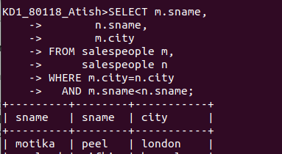

Que 2)write a query that produces the names and cities of all customers with the same rating as hoffman.
